The KGN Pillinger range of KIWA (Regulation 4) approved AV & EV Booster Sets are designed and manufactured for use in a variety of applications including water distribution or pressure boosting where the existing water pressure is unable to meet the demand requirements.

Advantages
- Pump performance range extended by shared duty operation
- Compact and bespoke design for custom fit installation

- Variable speed for optimum running costs
Design
- Available in horizontal or vertical bespoke format
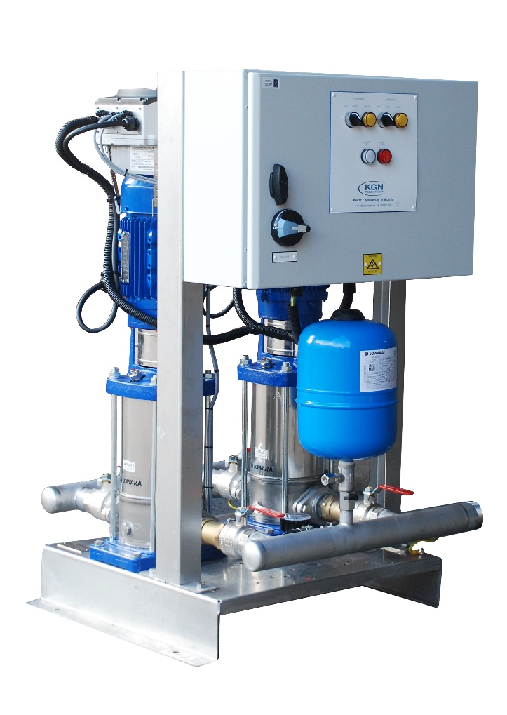
EV: Terminal box & Common volt free contacts (taken from inverters)
AV: Full control panel c/w individual volt free contacts

Applications
- Commercial properties
- Retail developments
- Apartment blocks
- Water utilities
- Agricultural
- Leisure centres
- Single dwellings
- Light industrial units
- Schools & universities
Features
- Stainless steel base frame
- Booster Sets available inside kiosks
- 316L stainless steel pipework as standard
- Individual motor mounted inverter drives on each pump
- Break tanks, filters and associated ancillary items available
- Single (EV) or Multiple (AV) BMS volt free contacts available
- Optional remote telemetry system to send fault signal alert via SMS text or telephone line
- Slow Fill system to prevent water surge following a power cut or if the unit cuts out due to low water level (AV)
- Anti-vibration mounts and flexible connections offered as standard to reduce noise transmission in the building

