The KGN Pillinger BTA places the Break Tank above our EV or AV Booster Set range on a stainless steel frame. With multiple tank sizes and dimensions available this unique design permits installation in even the most size restrictive plant rooms.

Advantages
- Efficient use of floor space
- EV or AV Booster set available
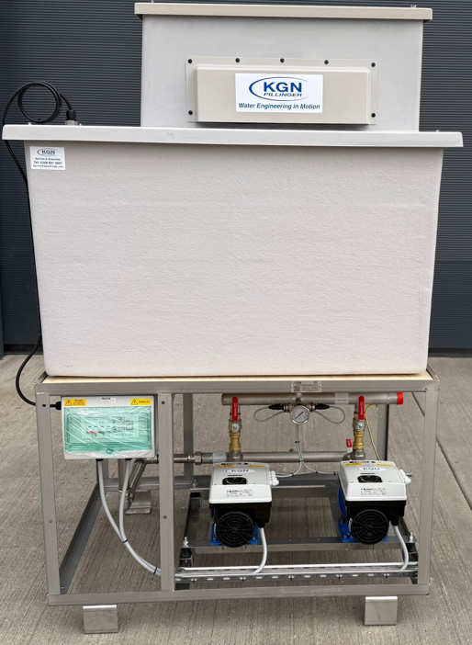
- Bespoke design for custom fit installation
Design
One piece or split horizontal tank seated on a stainless steel frame.

EV: Single or twin pump configuration AV: Multiple pump configurations
Applications
- Commercial properties
- Retail developments
- Apartment blocks
- Water utilities
- Agricultural
- Leisure centres
- Single dwellings
- Light industrial units
- Schools & universities
Features
- Stainless steel base frame
- Insulation of tank is 25 mm as standard
- 316L stainless steel pipework as standard
- Range of inlet valves in multiple sizes available
- Individual motor mounted inverter drives on each pump
- Single (EV) or Multiple (AV) BMS volt free contacts available
- A/B air gaps fitted as standard to offer complete protection for potable water mains
- Optional remote telemetry system to send fault signal alert via SMS text or telephone line
- Slow Fill system to prevent water surge following a power cut or if the unit cuts out due to low water level (AV)
- Anti-vibration mounts and flexible connections offered as standard to reduce noise transmission in the building

