The KGN Pillinger CAT 5 Washdown Booster Set is designed to prevent backflow contamination of the mains water supply, while maintaining flow and pressure. The unit is compact, lightweight, and housed in a stainless steel cabinet for easy wall mounting.

Advantages
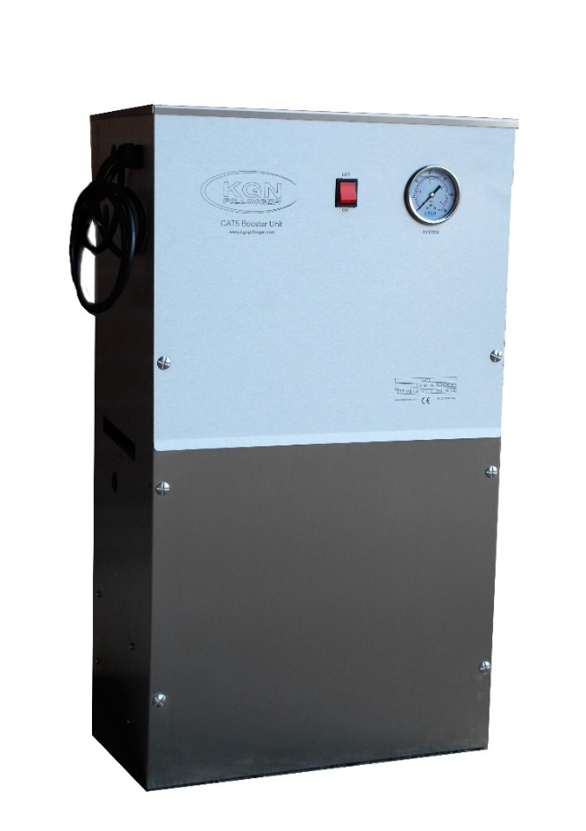
- Automatic operation
- Simple to wall or floor mount and install
- Easy access and maintenance
Design
Single diaphragm pump and water storage
tank house in a compact stainless steel cabinet
1 outlet connection only

Applications
- Bin store washdown
- Limited boosting applications
Features
- Standard stock item
- Illuminated ‘On/Off’ switch
- Duty: 0.25 l/s @ 2.2 bar (mid curve)
- Lightweight stainless steel cabinet
- Break Tank: 18 litre (4 gallon)
- Glycerine filled pressure gauge
- CAT5 AB Air gap to prevent backflow contamination
- Optional Extra: Cabinet can be fitted with a thermostat controlled heater
Dimensions Electrical Approx Weight
Width: 420 mm Watts: 0.37 kW 25 kg Depth: 370 mm Volts: 240 V Height: 750 mm Amps: 2.3 A

