The KGN Pillinger range of above ground pumping stations are designed for raising sewage and surface water in low lying areas for residential and commercial applications and are available on short lead times.

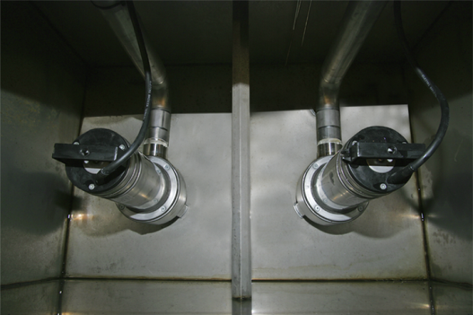
Advantages
- Designed around easy maintenance features
- Supplied packaged for simple installation
- Confined space training not required
Design
4mm 304 stainless steel precision engineered tank to any size
and fitted with stainless steel pipework throughout.
Applications
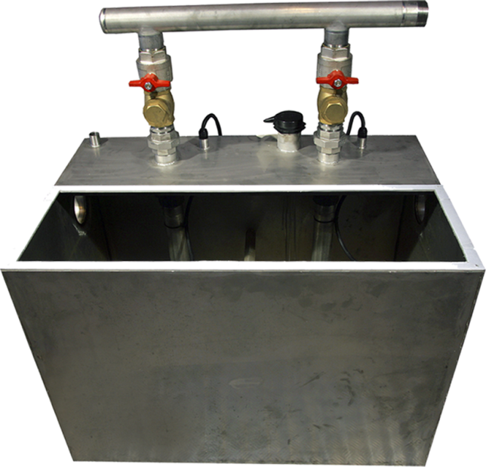
- Schools and universities
- Housing developments
- Light industrial units
- Apartment blocks
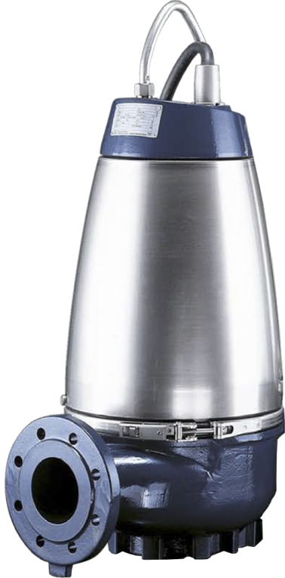
- Leisure centres
- Supermarkets
- Retail parks
- Factories
- Hospitals
Features
- Access lid
- 240v or 400v options
- Volt free contacts available
- External mimic control panel
- Air vent, overflow and drain valve
- Oracle telemetry system available
- Option for multiple connecting tanks
- One, two or three pump arrangements
- Individual pump isolator and non-return valves
- Tank has a channel base for ease of movement with forklift
- Available fully packaged or in kit form for installation by qualified personnel
- Electrode control for pumps including visual and audible high level warning fault system
- Pumps complete with cooling fins or jackets to prevent overheating when externally mounted

