The KGN Pillinger Range of ‘Fill Spill’ units are designed for maintaining pressure on larger sealed systems and built with 304 stainless steel tanks for longevity.

Advantages
- Available in bespoke design builds to fit within plant room constraints
- Capable of temperatures >120°C and extreme pressure changes
- Eliminates requirement for system expansion vessel
Design
Stainless steel tank connected to packaged booster set, comprising pump/s, control panel and expansion vessel on a single skid.

Applications

For use in larger heating systems where extreme pressure changes and high temperatures are likely.
- Commercial properties
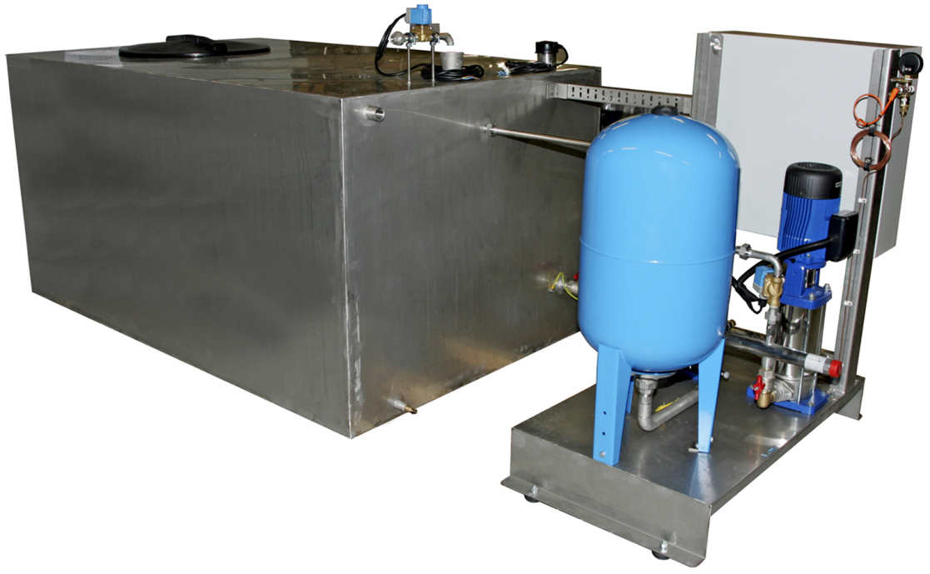
- Apartment buildings
- Leisure centres
- Industrial sites
- Water Utilities
- Office blocks
- Stadiums
- Hospitals
Features
- Multiple pumps configuration
- Multiple BMS volt free contacts
- Stainless steel base frame/skid
- 316L stainless steel pipework as standard
- Bespoke control panel for custom features and functions
- Bespoke stainless steel tank built to size with all connections
- Can be incorporated with other circulation and dosing equipment
- Inverter drive fitting available to achieve constant pressure control
- Remote telemetry system available to send fault signal alert via SMS text or telephone line
- Tank includes thermal spheres to reduce evaporation and assist in calming water at high temperature
- Anti-vibration mounts and flexible connections offered as standard to reduce noise throughout the building
- Can be supplied packaged with the tank on a common base fame or separate with interconnecting pipework between
the tank and the pump set

