The KGN Pillinger “E” Electronic range of Pressurisation Units are self-contained, fully automatic, PLC controlled and designed to maintain the required systems pressure in both heating and chilled water systems.

Advantages of a sealed system
- Elimination of corrosion due to the lack of contact between air and water within the system
- Automatically pumps water into the system(s) to maintain the correct set pressure
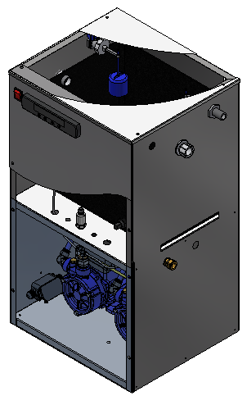
- Eliminates the need for a large tank within the roof space of a building
Design
All incorporate bronze pumps which are housed in a brushed 304 stainless steel
cabinet suitable for floor standing or wall mounting.
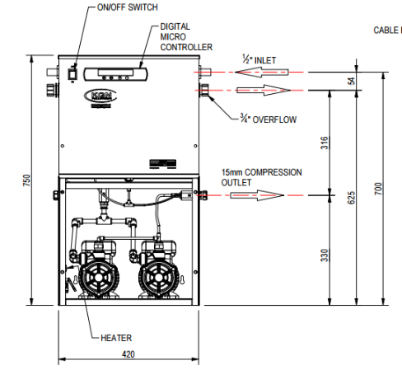
SE300E: Twin pump single system

Features
- PLC controller
- Heavy duty fill pumps
- Pipework: Nylon push fit
- Pump protection: MCB(s)
- Pressure regulating valve
- Tank low level cut off switch
- High and low pressure output
- Break tank: One 18 litres (4 gallons)
- Designed for system pressures up to 6 bar
- Automatic pump duty changeover per operation
- Additional expansion vessel(s) can be calculated and supplied upon request
- Pre-assembled with high and low pressure cut out VFC terminals for boiler and chiller interface
- Common VFC for unit fault

- Visual Indications: Illuminated mains on switch and visual readout on PLC display.
- Polypropylene tank incorporating air gap, ball/float valve (DN15 BS21) and overflow (DN22 BS21)
Dimensions Electrical Weight
Width: 420 mm Watts: 0.75 kW 38.5 kg Depth: 370 mm Volts: 240 V or 400 V Height: 750 mm Amps: 3.41 A or 1.59 A

