KIWA (REG4 compliant) approved fully fitted underground GRP plant room incorporating packaged booster set and storage tank. The base is constructed from GRP encapsulated support runners which should be lowered onto a flat continuous foundation. Integrated wall stiffeners allow a dry lean mix backfill to be poured around the housing. A slab can then be cast directly onto the UPOD cover or a precast slab placed over the top.

Advantages of a UPOD
- Installed underground leading to space saving for the development by removing the need for a plant room
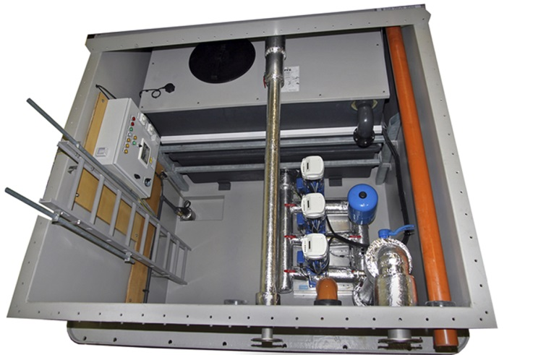
- No noise issue from the operation of the pumps
- Avoids the requirement for planning permission
Design
Standard size UPOD1100-9600 refers to the actual litres
capacity of the storage tanks within the UPOD. Larger
sizes and divided tanks are available. Divided tanks
are beneficial by providing the option to continue
operation when cleaning one side of the tank
Features
- 316L Stainless Steel pipework
- Heater, light and power socket
- Electrode activated sump pump
- 2 year warranty (Terms and Conditions apply)
- Supply and extraction fans for increased ventilation
- Pipework fully lagged to reduce condensation in the unit
- Above ground mimic panel for monitoring of UPOD control panel
- All mechanical connections made outside the unit in a designated ‘termination area’
- Solenoid valve fitted to the incoming water supply which will shut in case of emergency
- Multiple pump configurations available for varying flow and pressure to suit project requirements
- Slow fill system to prevent water surge following a power cut or if the unit cuts out due to low water level
- Telemetry available as optional extra to send fault signals out to remote locations via SMS text or telephone line
Dimensions
Length: Variable depending on tank size
Width: 2850 mm Depth: 2580 mm
A smaller compact version of the UPOD is also available with a tank size of 280 litres. Contact our sales team for more information on these and the complete range of KGN Pillinger water boosting equipment, pressurisation units and stainless steel fabrication.

